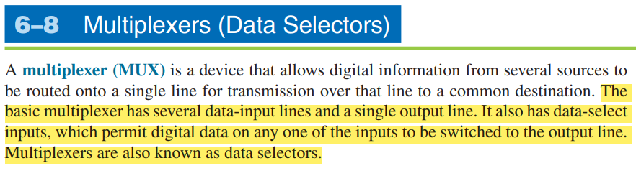

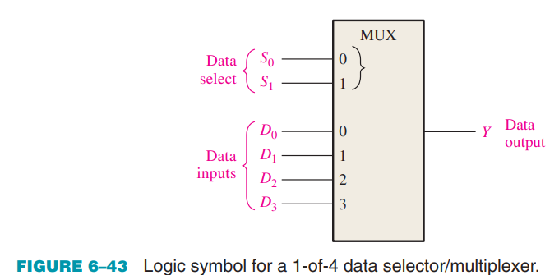

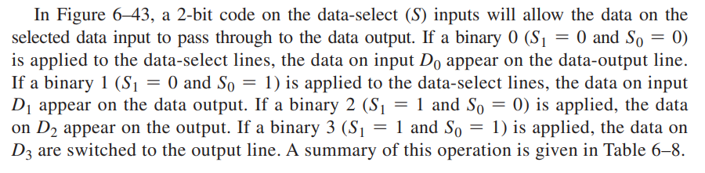

For example, with two select lines, the multiplexer can choose between four different inputs (2^2 = 4 combinations), and with three select lines, it can choose between eight different inputs (2^3 = 8 combinations), and so on.

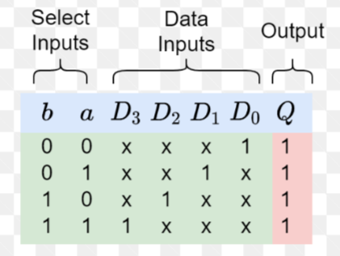

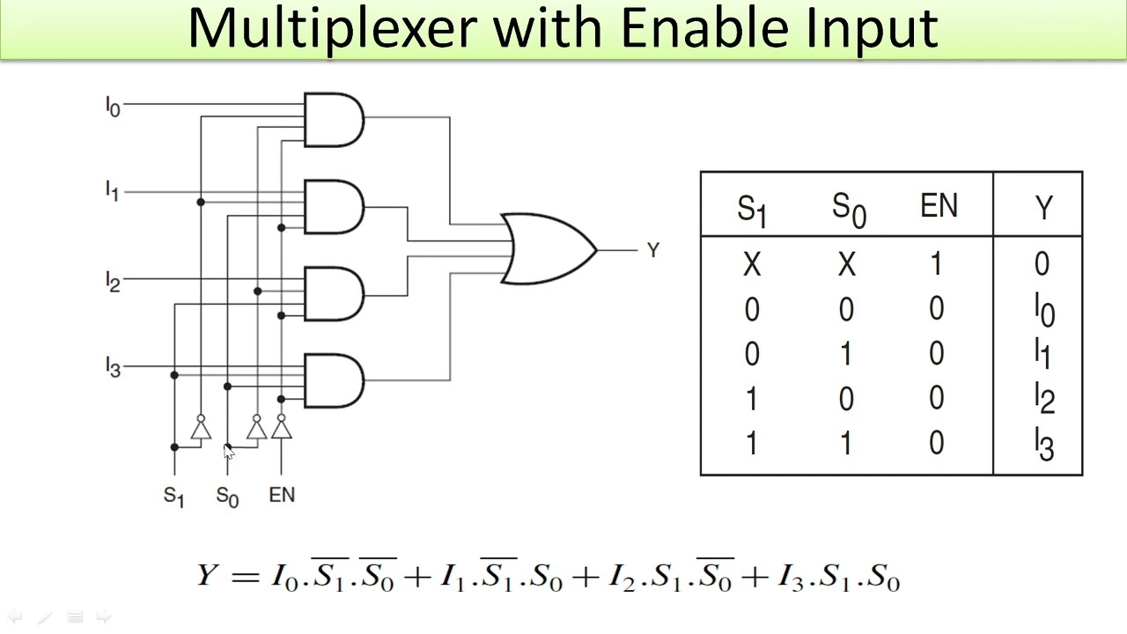

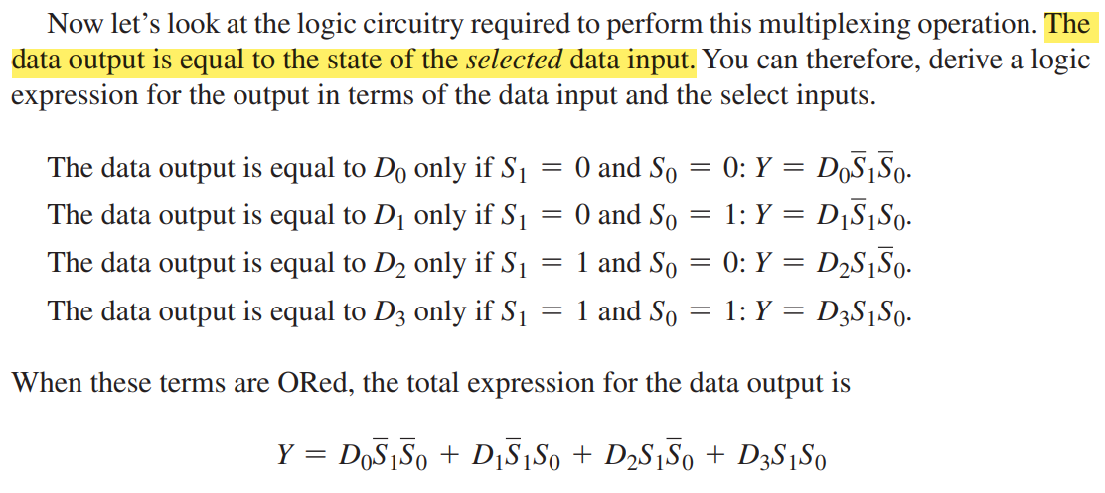

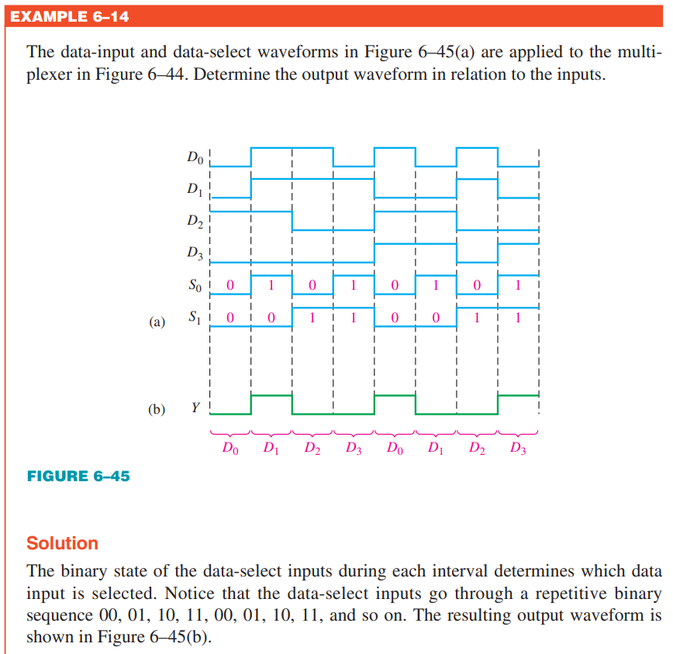

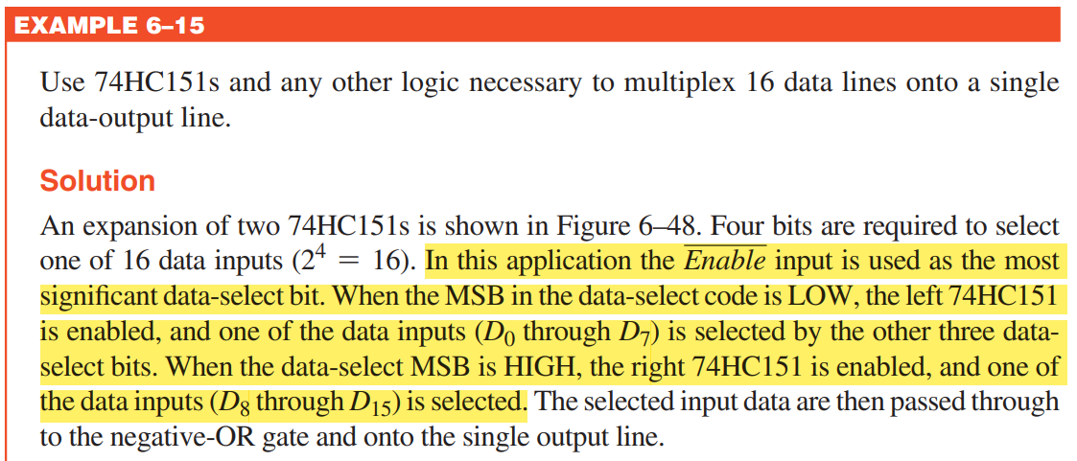

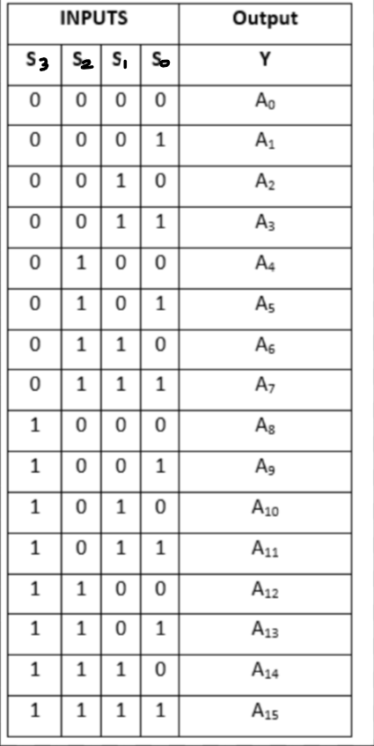Look at the S3, it is working as a Enable pin in the IC, if it is **LOW**, the LSB side (first IC) will work, if it is **HIGH**, the MSB side (Second IC) will work.

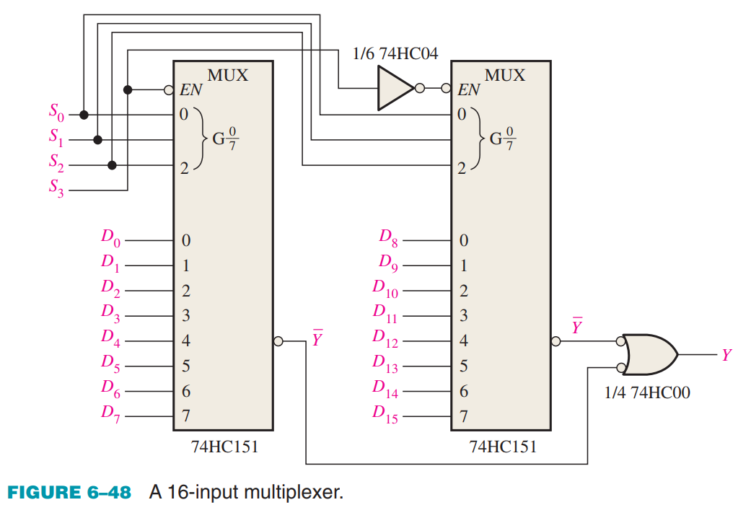

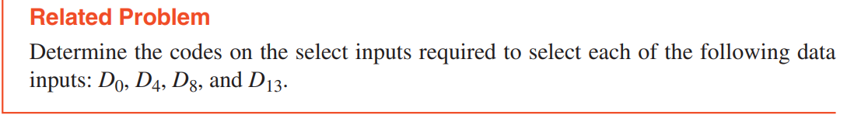

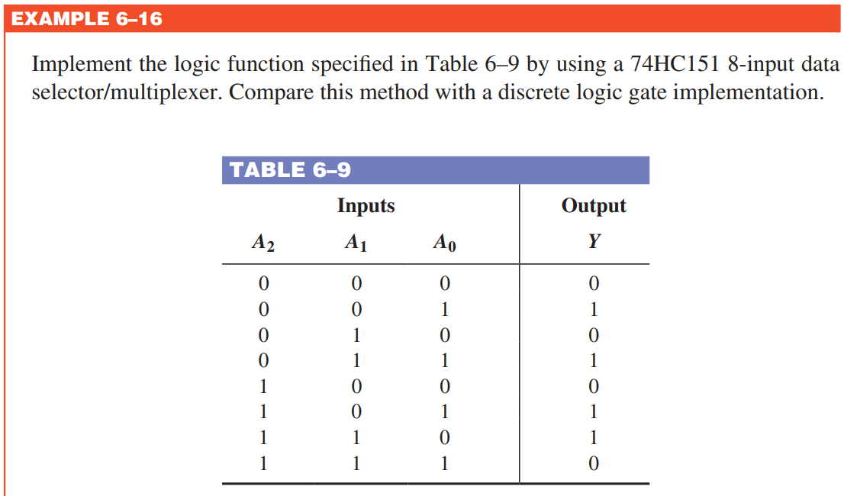

Look at the given table, the data (values) for data inputs (D0, D1, D2 etc) is given, provide the input data to data pins so that when a data pin is selected, the provided data input is acquired at the output.

